New School App and
Parents Evening On-line booking system.

Dear Parents/Carers of:
Class:

Parents Evening will be held on the 16th & 17th of January 2018. This is an opportunity to come in to school and discuss your child’s progress with their teacher.

This year we are pleased to be launching a new on-line process for booking appointments through our new school app or the website. The School Spider App allows parents to receive communication from the school quickly and easily. This includes direct messages to parents, parents evening booking, surveys and forms and more. It is directly linked to our school website. This means that communication will be much improved.

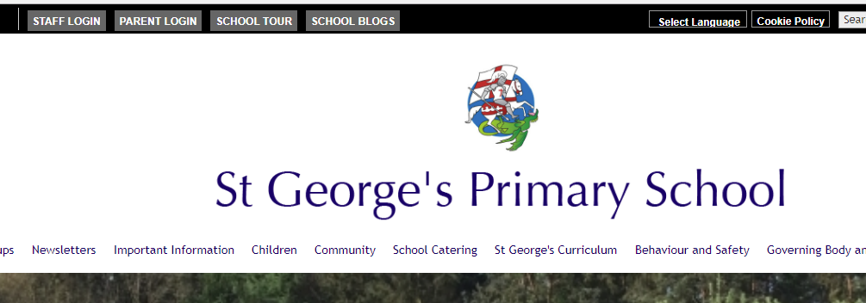
You can download the app for free from the Apple App Store or Google Play on Android phones.

If you do not have access to a smartphone/tablet you can still book parents evenings, complete surveys and forms etc via the parent log in on the school website. You can log in via the parent login tab on top black bar on the school homepage.
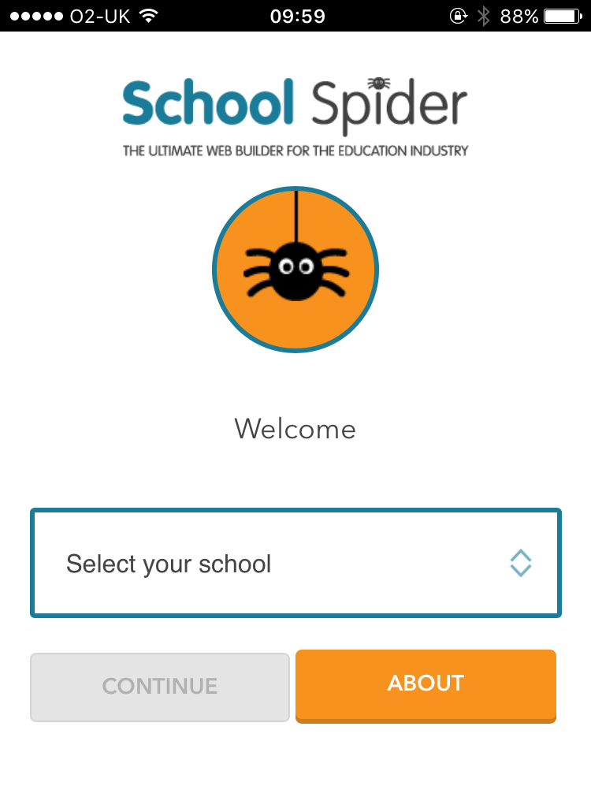
Using the app
- Download the app from Google Play or Apple App Store.

- When you download the School Spider app you will need to select your school using the drop down bar such as on the picture on the left.

Once you have selected the school you want to view, you can access any recent news/calendar/gallery/blogs which have been posted to the website. You need to log in as a parent to be able to receive communication.

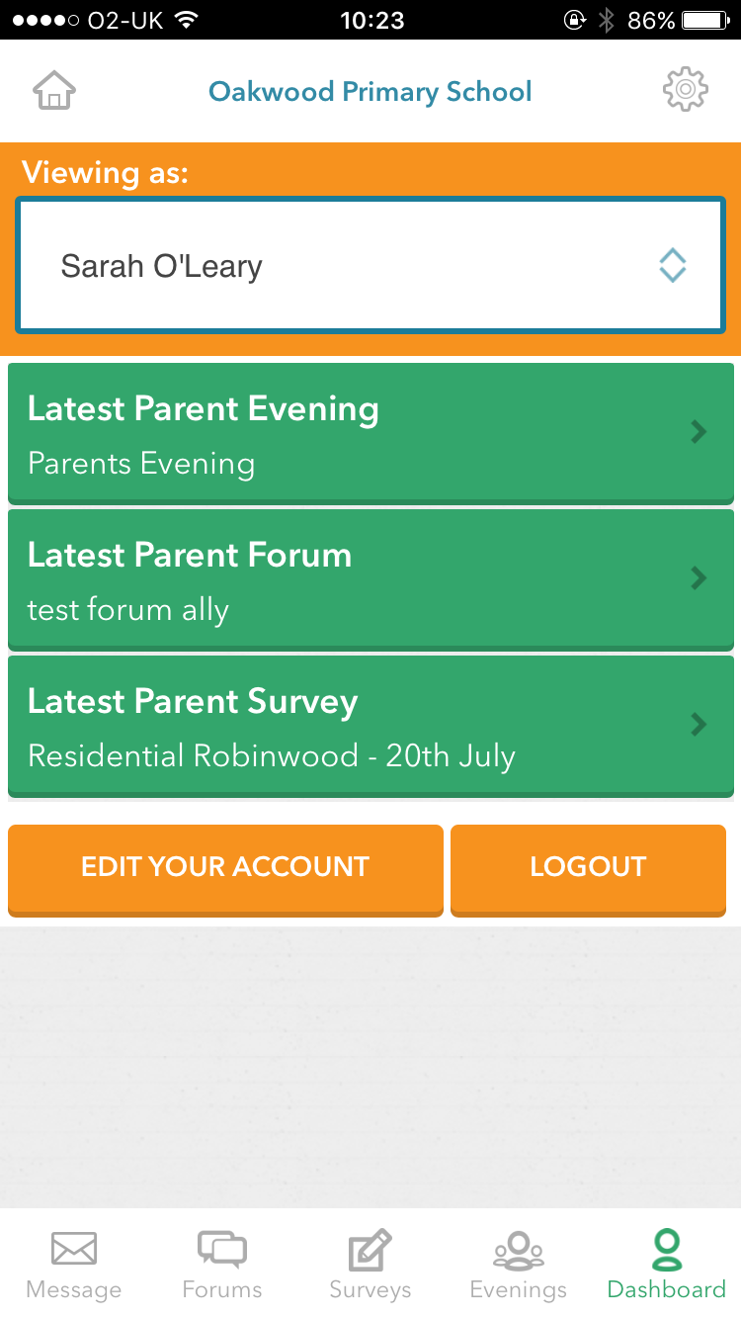
- Select login as a parent to input your username and password. Here you can see the child you are viewing (you can select the child‘s name to select a different child if you have multiple children at the school) You can select edit your account to change passwords and personal information.

Your Log-in details are as follows;

User Name:

Password:

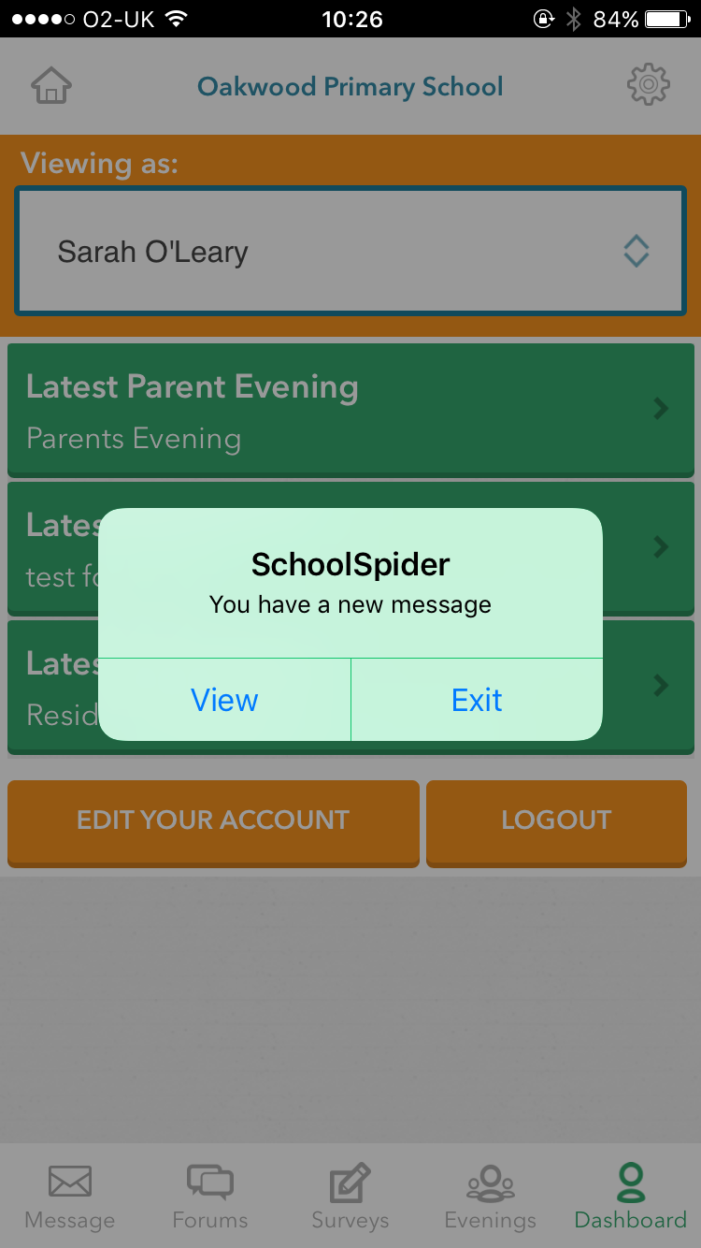
Once you are logged in, you don’t need to do anything. You will then start receiving messages either direct or to ask you to complete surveys, book parents evening etc.

Once you view the message, if it is asking you to complete a form or to book a parents evening a notification will pop up over the icon at the bottom of the dashboard.

Booking parents evening and completing surveys and forms are very self-explanatory. Below shows how a parents evening looks when you log on and once you have booked your slot.
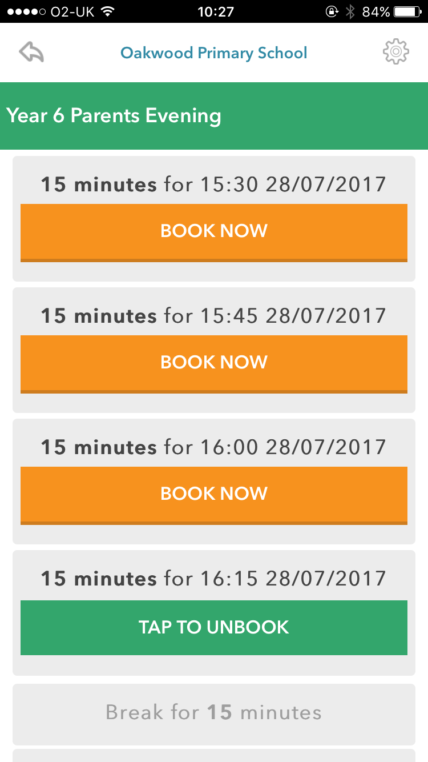
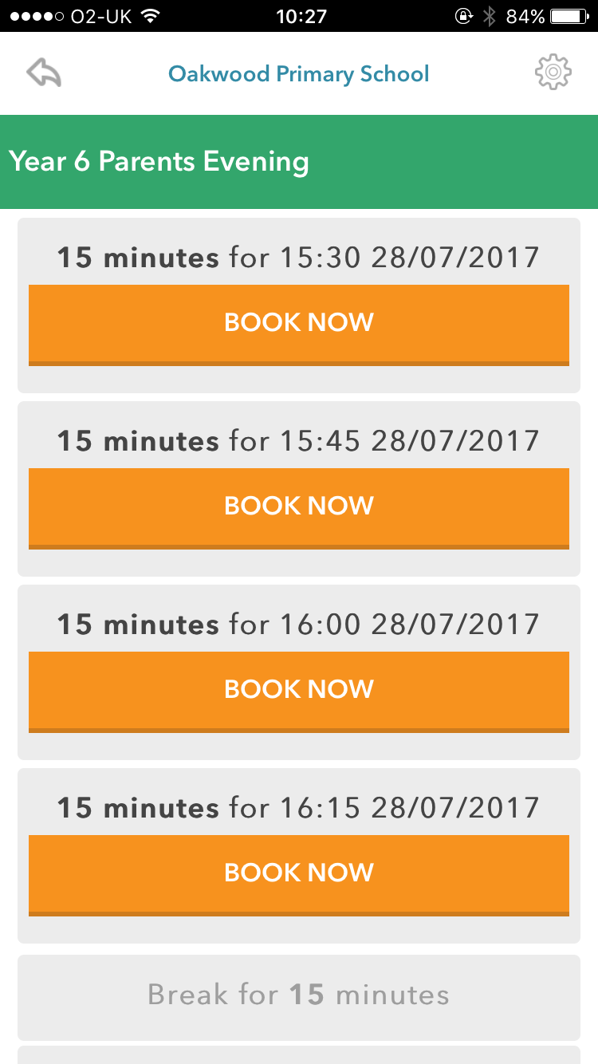

If you can’t access the internet or apps, please contact the front office directly who will arrange a parents’ evening appointment for you.

Making Free School Meal Applications Easier;

We are also introducing a new piece of software to school that will assess eligibility for Free School Meals which would ensure Pupil Premium funding in to school. This software will make the application process easier and more confidential for parents. School will require your NI Number and will have a form ready at Parents Evening if you are happy to opt in.

Many thanks
School Office

