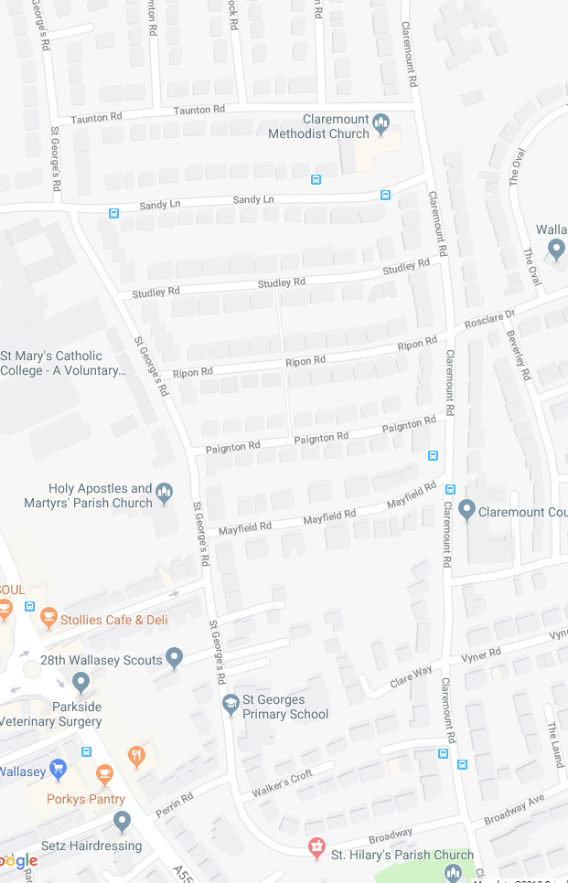
St George’s Upper Site

Sandy Lane

St George’s Lower Site

Broadway

