Google Classroom

Enter Google Classroom into your search engine, or if using a tablet, download the app.

The second link (classroom.google.com) will take you to the log in page for Google Classroom.

Make sure you are logged out of any other Gmail accounts. Enter your child’s Google Classroom email address and password which they have been given on their password sheets.

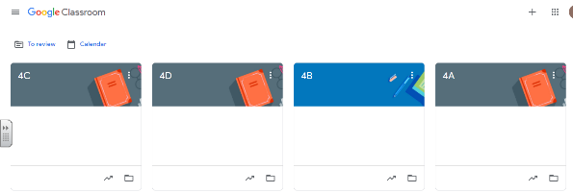
Once you have logged on, you will be able to click on your child’s class and view the maths and spelling homework they have been set for the week.

Spelling Shed
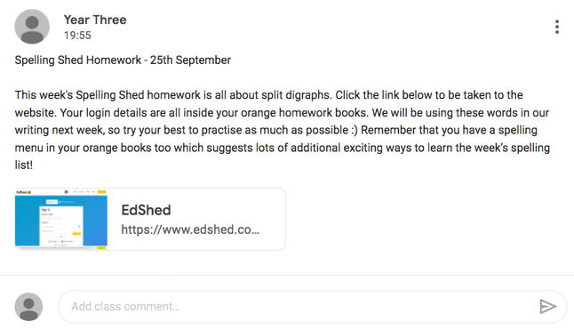
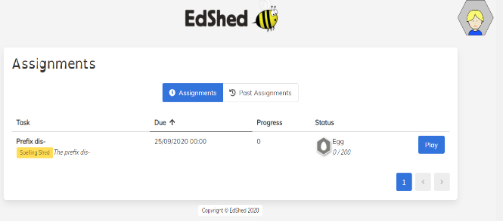
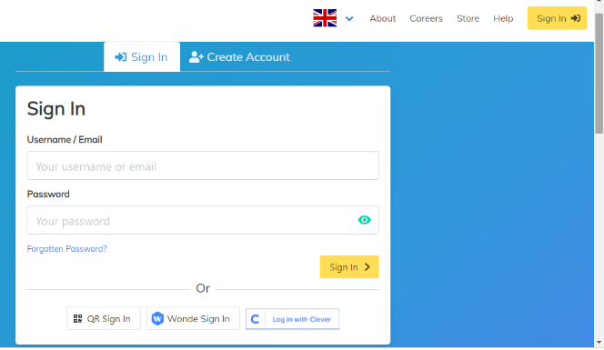
Click ‘Play’ on the far right and your child will be able to play the games linked to the spelling rules they have been learning in school.
Once logged in, you will be taken to a page that displays the assignments your child has been set. Click ‘view’ and this will take you to where your child can view all current work.
At the top right of the website is a yellow ‘Sign In’ button, this will take you to where you can use your child’s username and password to log in. Login details are found in the orange homework books.
Underneath the assigned homework there is a link to the Spelling Shed website, where the spelling homework will be set.

