Help Plan Mr Cassidy’s South American Adventure Competition
Dear Year 6,
I have loved seeing your home learning projects this week and sharing your enthusiasm for South American geography and culture.
When I retire (in about 20 years!) my plan is to visit South America for 3 months. I want to travel from north to South and see all the great sites.
I would like your help with this. Can you plan a trip itinerary for me?
I will let you plan the trip but there are four destinations that MUST be on the trip. They are:
- Los Roques Archipelago (Archipiélago Los Roques)
- Galapogas Islands
- Patagonia
- Deception Island
You can plan the rest of the trip for me. 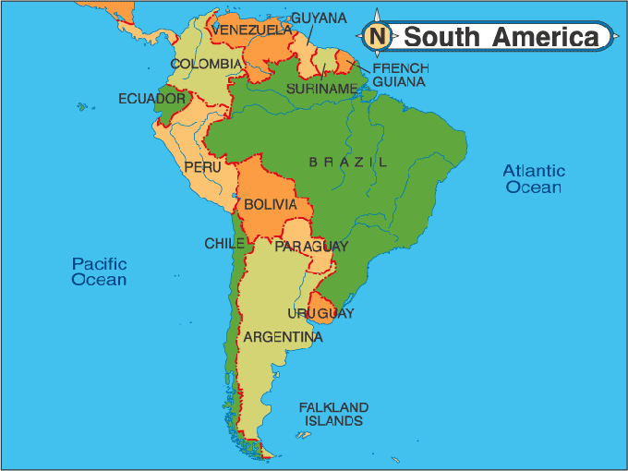
I need to know:
- Where I will be going.
- Route I will take.
- How I will get there. I am happy to travel by road, air, sea and train through South America.
I would like your plan sent to me by January 8th 2021. You can do this by giving them to Mrs Jones in the front office or e-mailing them to joanne.jones@stgeorges.wirral.sch.uk.
You do this on paper, Power-Point, Word file, podcast, video file or any other format that you would like to use.
The best itinerary will win a £25 Amazon Voucher. They will be judged for detail, creativity and presentation. Everybody who takes part will receive an award.

